DNA accessibility history reveals differential regulatory functions during hematopoiesis cell development.
Guanjue Xiang, Belinda Giardine, Lin An, Cheryl A. Keller, Elisabeth Heuston, David Bodine, Yu Zhang, Ross C Hardison

Abstract

Transcription factors bind to DNA accessible regions to regulate gene expression during cell development. It is however unclear which DNA accessible regions are important for cell type development at certain stage. To address this question, we developed a method for inferring the history of DNA accessible regions along the tree of hematopoiesis cell development and their relationship with regulatory functions.

Using ATAC-seq data in a system containing 16 mouse hematopoietic cell types (VISION project and Amit lab), we identified 153,636 DNA regions that are accessible in at least one cell type. To visualize and interpret the accessibility history of these regions, we introduce a hierarchical visualization method for any given hierarchy of cell types, where different cell type hierarchies may be used to reveal the accessibility history and the associated DNA regions specific to certain linage of cell development.

Availability and implementation: https://github.com/guanjue/CD_viewer

Introduction

Recently, the projects such as ENCODE, ROADMAP, VISION have generated a large amount of epigenetic data for cell types in certain cell development stages. So, understanding the roles of a certain epigenetic mark in different cell types during cell development has become a very hot topic. However, how to analyze certain epigenetic information across multiple cell types has become a challenge in this field.

To deal with this challenge, one commonly used strategy is to do peak calling for different cell types. Then using unsupervised clustering methods such as K-means clustering method or Hierarchical clustering method to cluster the DNA regions based on their presence/absence pattern or signal strength of the target epigenetic mark in the different cell types. [] After the clustering, researchers can identify meaningful clusters and further investigate the function of the DNA regions in these clusters. However, one downside of the simple unsupervised clustering method is that they may produce some clusters that are very hard to interpret by biologists. It is because the clustering result is driven by the data without incorporating the previous existing background knowledge of the biological system, such as the cell type relationships.

Here, we developed a method called cell-develop-viewer (CD-viewer) to address this issue. The CD-viewer can group and visualize the DNA regions based on their ATAC-seq signal along the cell types development path. Based on the result, our method can provided a relatively clear way to visualize accessibility history of the DNA regions during the cell development.

2 Implementation

2.1 Input data for CD-viewer

The CD-viewer needs three input files. The first one is the file of peak-cell-type matrix. In the peak-cell-type matrix, each cell represents the signal of a certain peak in a certain cell type. The second one includes the signal clusters and the corresponding lower and upper limits. The third one is the file indicates the cell type order in the interested development path.

2.2 Identify index set and sort index for development path

The peak signal matrix will be converted to signal clusters based on user defined signal cluster groups.

The cell types will be sorted based on the user-defined order based on previous biological knowledge.

The peaks will be split into two groups based on their presence/ absence pattern in the each cell type.

2.3 Visualize index matrix and index set matrix

The CD-viewer needs three input files. The first one is the file of peak-cell-type matrix

2.2 Identify DNA regions with specific accessibility patterns during hematopoiesis cell development

Here, we focused on 16 mouse hematopoietic cell types in VISION project and Amit lab that have ATAC-seq data. [] The corresponding cell type development tree is shown in figure 1. First, Homer is used to do ATAC-seq peak calling for all replicates of the 16 cell types and the short intervals of the Homer output are considered as ATAC-seq peaks (>100k peaks). [] These peaks are merged by bedtools with at least 1 bp intersection. The merged peaks that are found (1) in at least two cell type replicates if replicates available or (2) called in a cell type with no replicate available are kept. Then we get 211,814 DNA regions. [] Next, these 211,814 DNA regions are used to intersect with the peaks that are called in each cell type.

If a DNA region intersects with at least one peak that are called in both replicates of a cell type with ATAC-seq replicates, the DNA region is labeled as presence (1) in that cell type, otherwise labeled as absence (0). If a DNA region intersects with at least one peak that are called in the sample of a cell type WITHOUT ATAC-seq replicates, the DNA region is labeled as presence (1) in that cell type, otherwise labeled as absence (0). So each DNA region among the 211,814 DNA regions will an vector of 16 digits represent the presence/absence (1/0) in certain cell types.

Figure 1, Cell types involve in the hematopoietic cell development and the corresponding cell development tree. (LSK), (CMP), (MEP), (GMP), (CLP), (CFU-MK), (MK), (CFU-E), (ERY), (G1E), (ER4), (EOS), (Mast), NEU, MONO, T CD4+, T CD8+, B, (NK).

Group DNA regions based on their accessible history during mouse hematopoietic cell development

Here, we are interested in one specific development path. In figure 1, we can see the CMP-cell can develop into MEP-cell or GMP-cell. However, only the MEP cell can further develop into MK cell and ERY cell. We hypothesized that some specific DNA regions may change their accessibilities in MEP-cell and/or GMP-cell. So the gene regulators specific for MEG-cell and ERY-cell development can bind to the DNA region and regulate these two development processes.

Instead using an unsupervised clustering method to cluster the DNA regions based on their 16 digits vector, we apply a decision tree to give different priorities to the DNA regions’ 1/0 labels in different cell types. Specifically, we first ordered each DNA region’s 16 digits vector based on the development path we are interested in. To understand the difference between MEP-cell and GMP-cell, we focused on the left part of the cell type development tree in figure 1. So, the order we used is as follows: 1st, LSK-cell; 2nd, CMP-cell; 3rd, MEP-cell; 4th, GMP-cell; 5th, CFU-MK-cell; 6th, MEG-cell; 7th, MONO-cell; 8th, NEU-cell; 9th , CFU-E-cell; 10th , ERY-cell; 11th, G1E-cell; 12th, ER4-cell; 13th,B-cell; 14th, NK-cell; 15th,T-cell with CD4+; 16th, T-cell with CD8+. Then, we give higher priority to the 1/0 label of cell type with smaller rank number.

For example, we gave the highest priority to the 1/0 label of the LSK-cell (rank 1st), which is the progenitor cell of all cell types in the entire development tree. So, we split the DNA regions into two groups. The DNA regions inside the first group indicate they are accessible in LSK-cell. The DNA regions inside the second group indicate they are inaccessible in LSK-cell. Then for DNA regions in group1, we further split them into two subgroups based on their 1/0 label in CMP-cell (rank 2nd). After walk through the entire cell type development tree, each DNA region among the all of 211,814 DNA regions is put into a group with specific 1/0 pattern correspond to the cell type order. We called the 16 digits of 1/0 pattern as index. We called all DNA regions with the same index as index set. (Figure 2) We identified 8190 index sets in total.

Figure 2, The strategy we used to group the DNA regions based on their position during the cell type development. For plotting issue, we only showed the first four cell types of the decision tree we used in this study.

Identify important index sets

Before visualizing the index set, we first checked the number of peaks in each index set and found the range is from 1 to 10,329 (figure 3). So index sets with small number of DNA regions may shadow the index sets with a large number of DNA regions. To deal with this problem, we hypothesized that the index sets with larger number of DNA regions are more important. So for all index set in the downstream visualization, we required there must be at least 200 DNA regions in the index set. After this filter, we get 118 index sets for the 16 hematopoietic cell types that include 153,636 DNA regions (figure 5a).

Figure 3, the distribution for number of DNA regions in a given index set. Based on this figure, we set 200 as the minimum number of DNA regions in a given index set for including the index in downstream visualization.

Identify most informative epigenetic state for each index set

(a)
(b)

Figure 4, (a) Epigenetic states that are identified by IDEAS.
(b) Methods to identify information epigenetic state for each index set.

Result

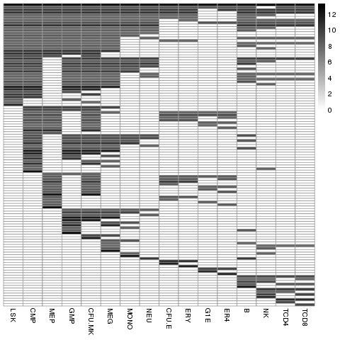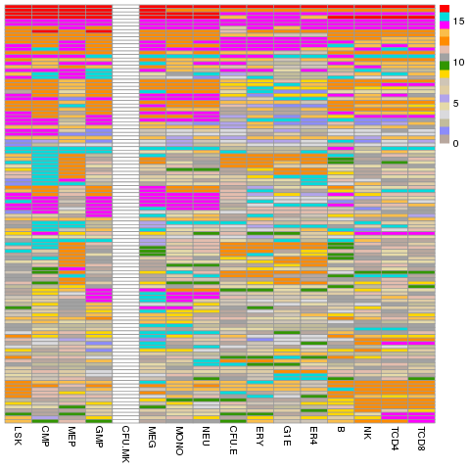
(a) (b)
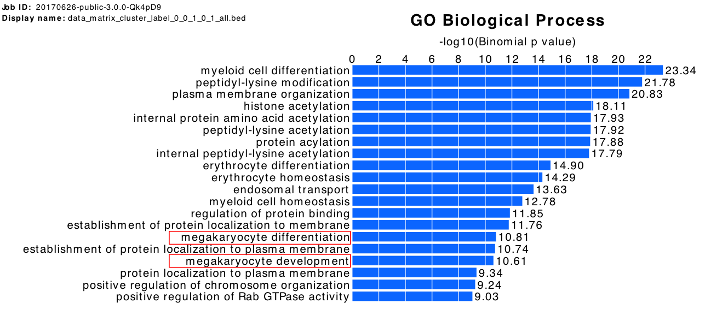
(c)
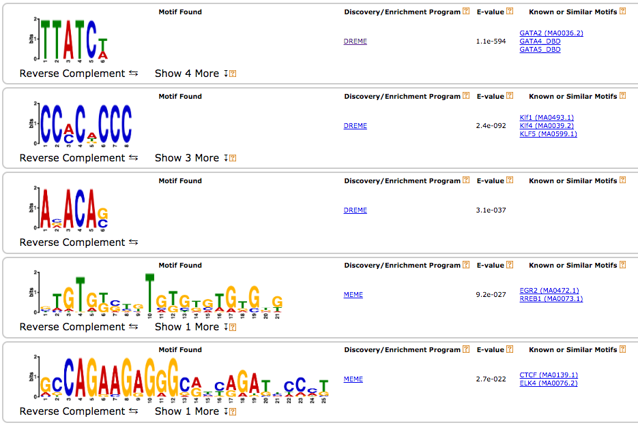
(d)

Figure 5, (a) 118 index set visualization. Each row represents the 1/0 pattern of a certain index set. Each column represents a cell type among the 16 cell types. A Black cell means all DNA regions in a certain index set are accessible in the corresponding cell type. The color density represents the number of DNA regions in that index set. (b) Most enrich epigenetic state

Discussion

Conclusion:
1, our method is able to visualize the peaks in multiple cell types.
2, It can clearly show the history of the accessible history of the peaks.
3, The epigenetic state of the clusters indicates the cluster is meaningful.
4, It can be a very handy software to visualize the peaks in multiple cell types.

